1.passport management system

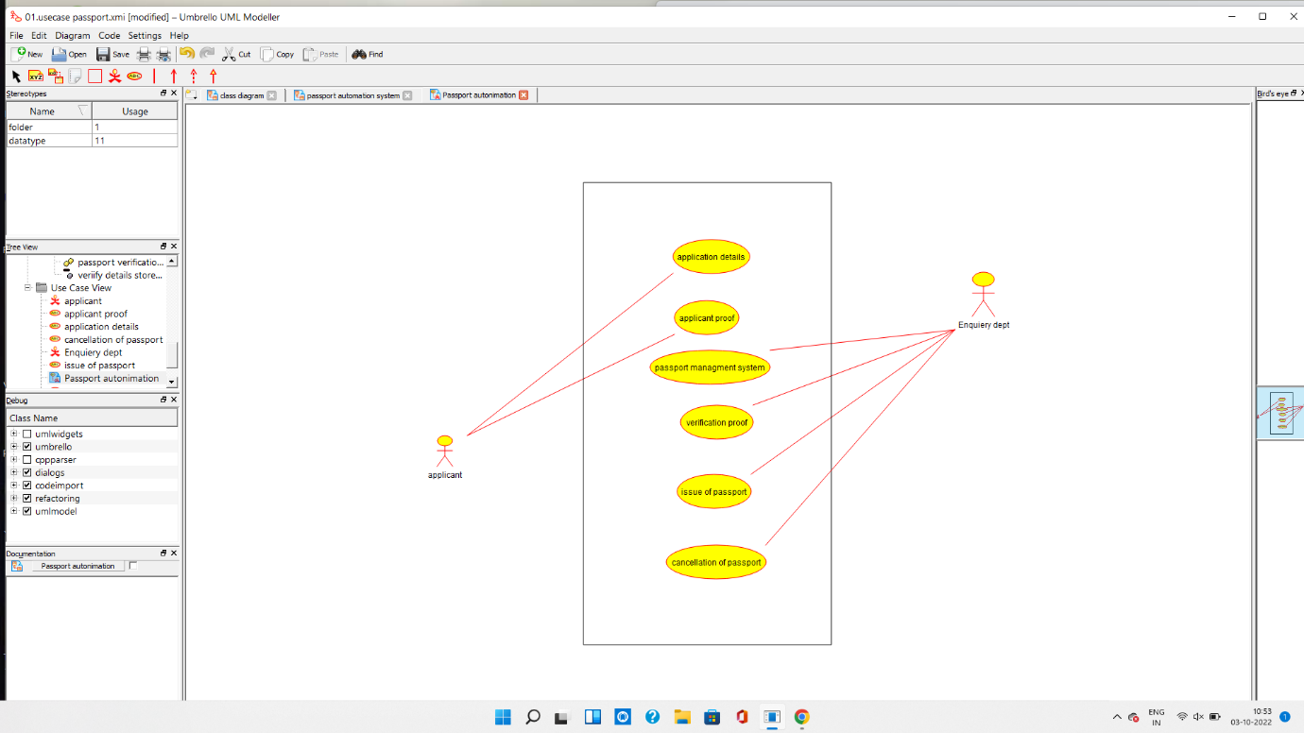

1.usecase diagram

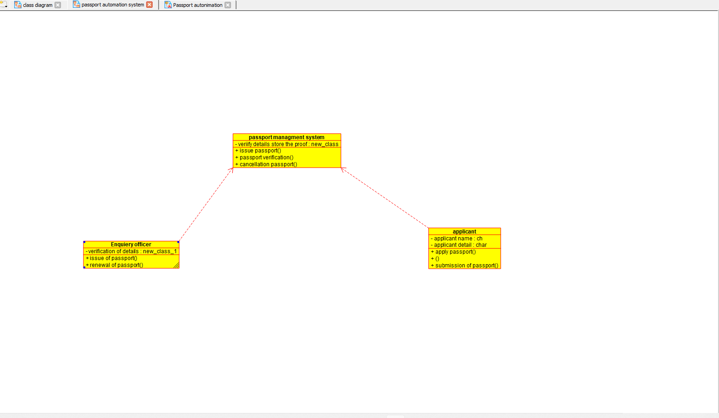

2.class diagram

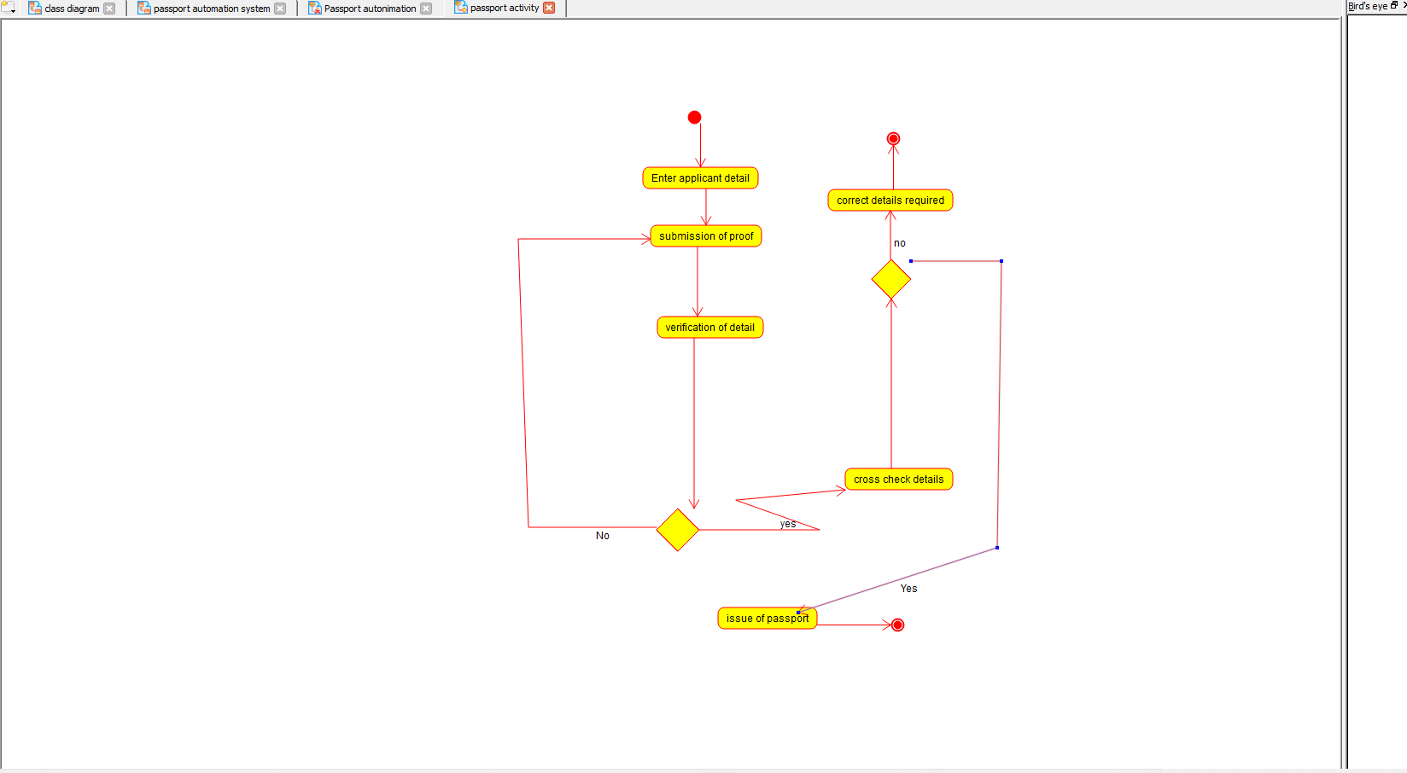

3.activity diagram

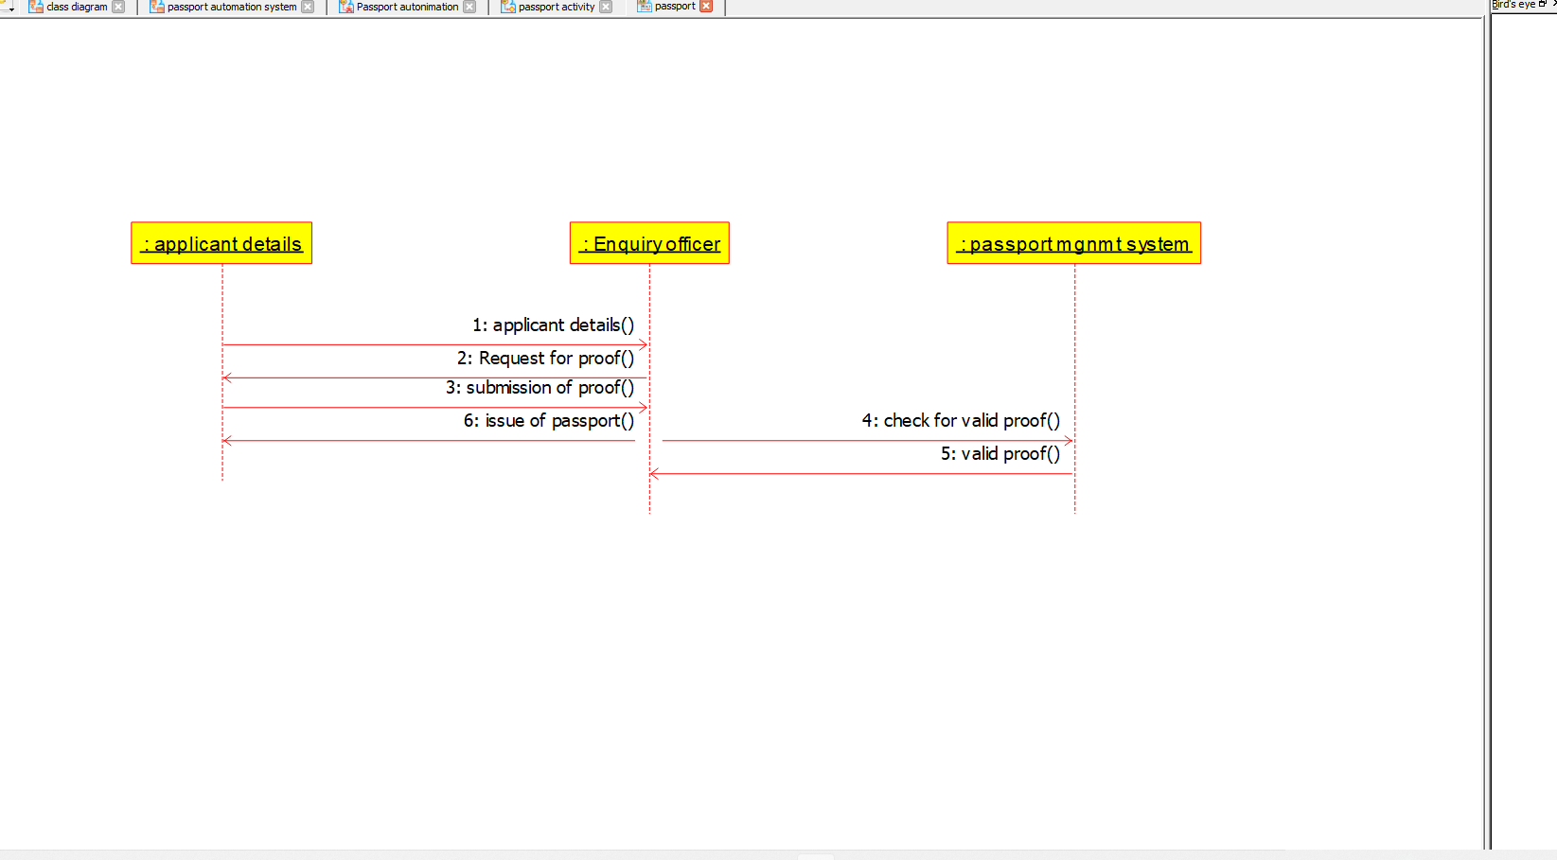

4.sequence diagram

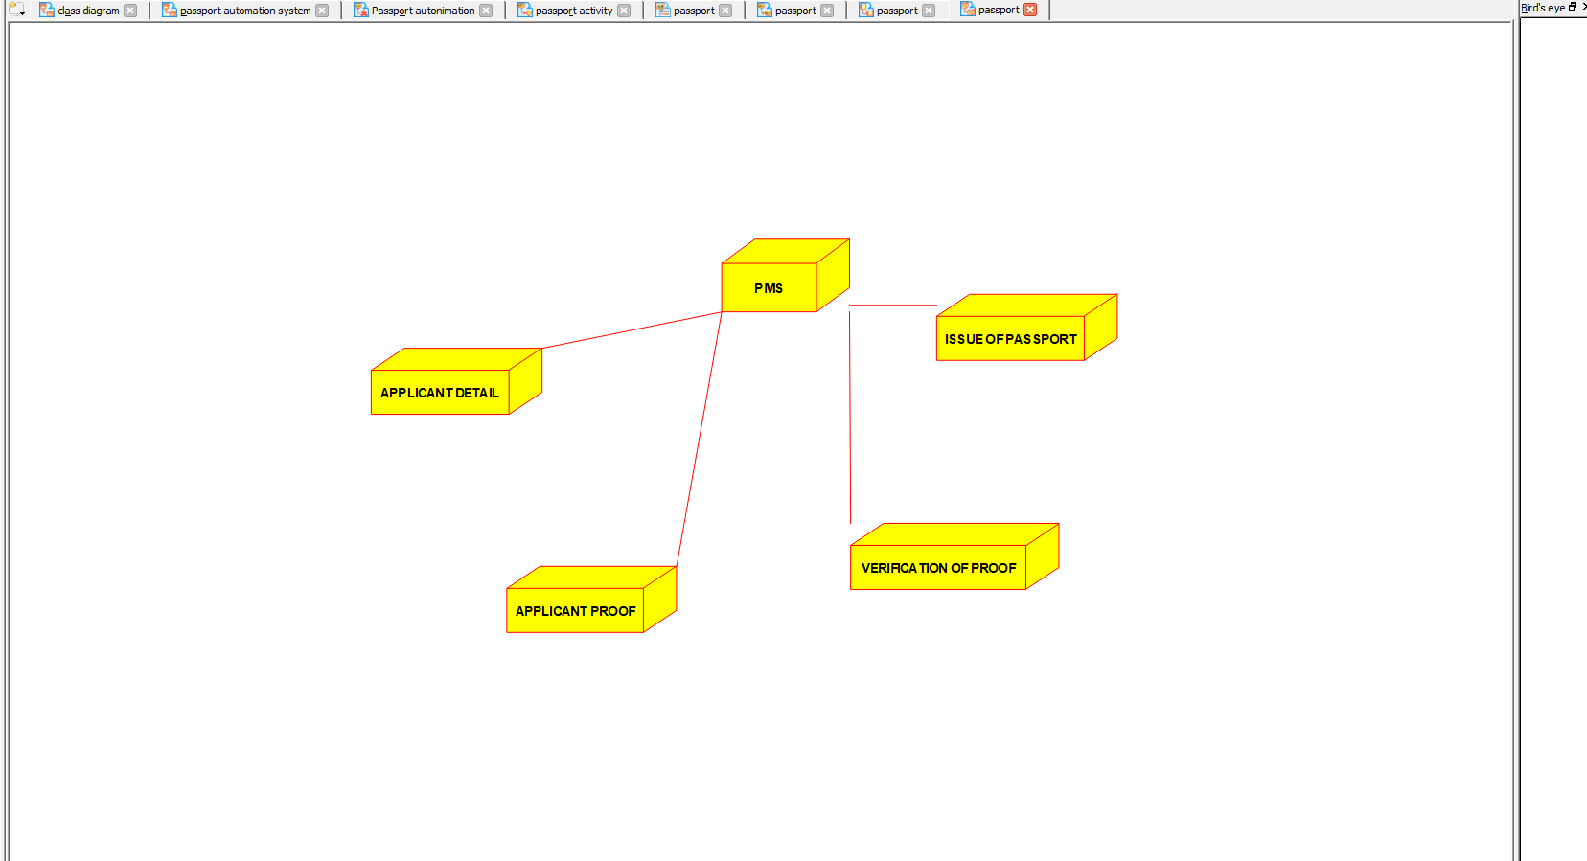

5.deployment diagram

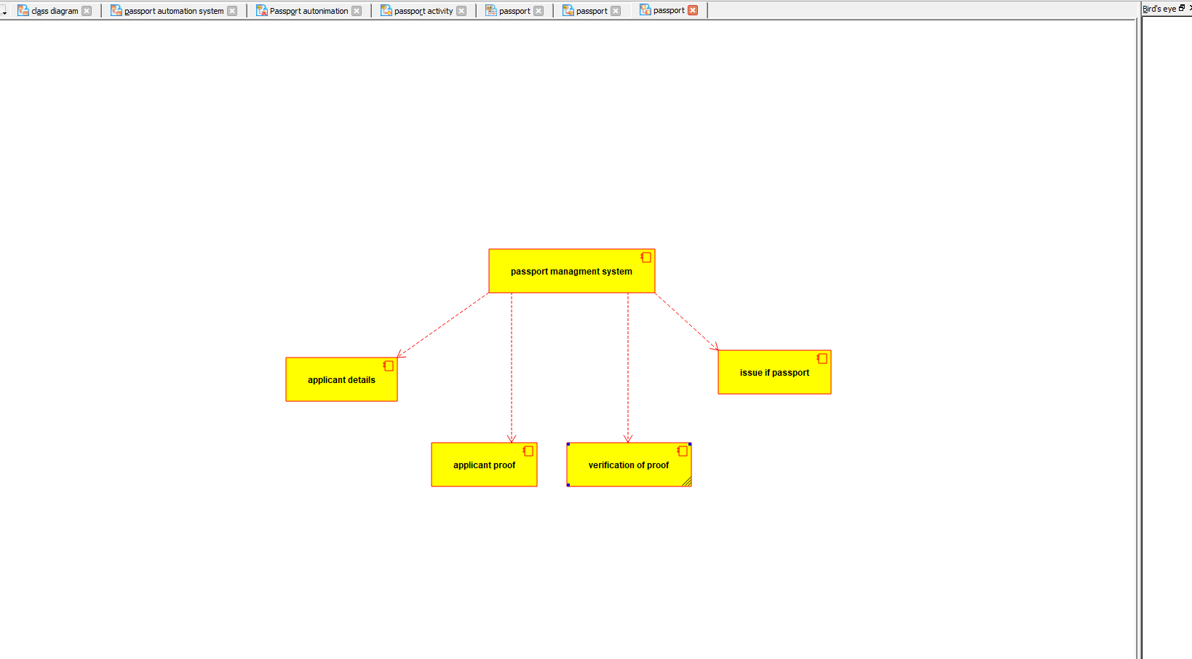

6.component diagram

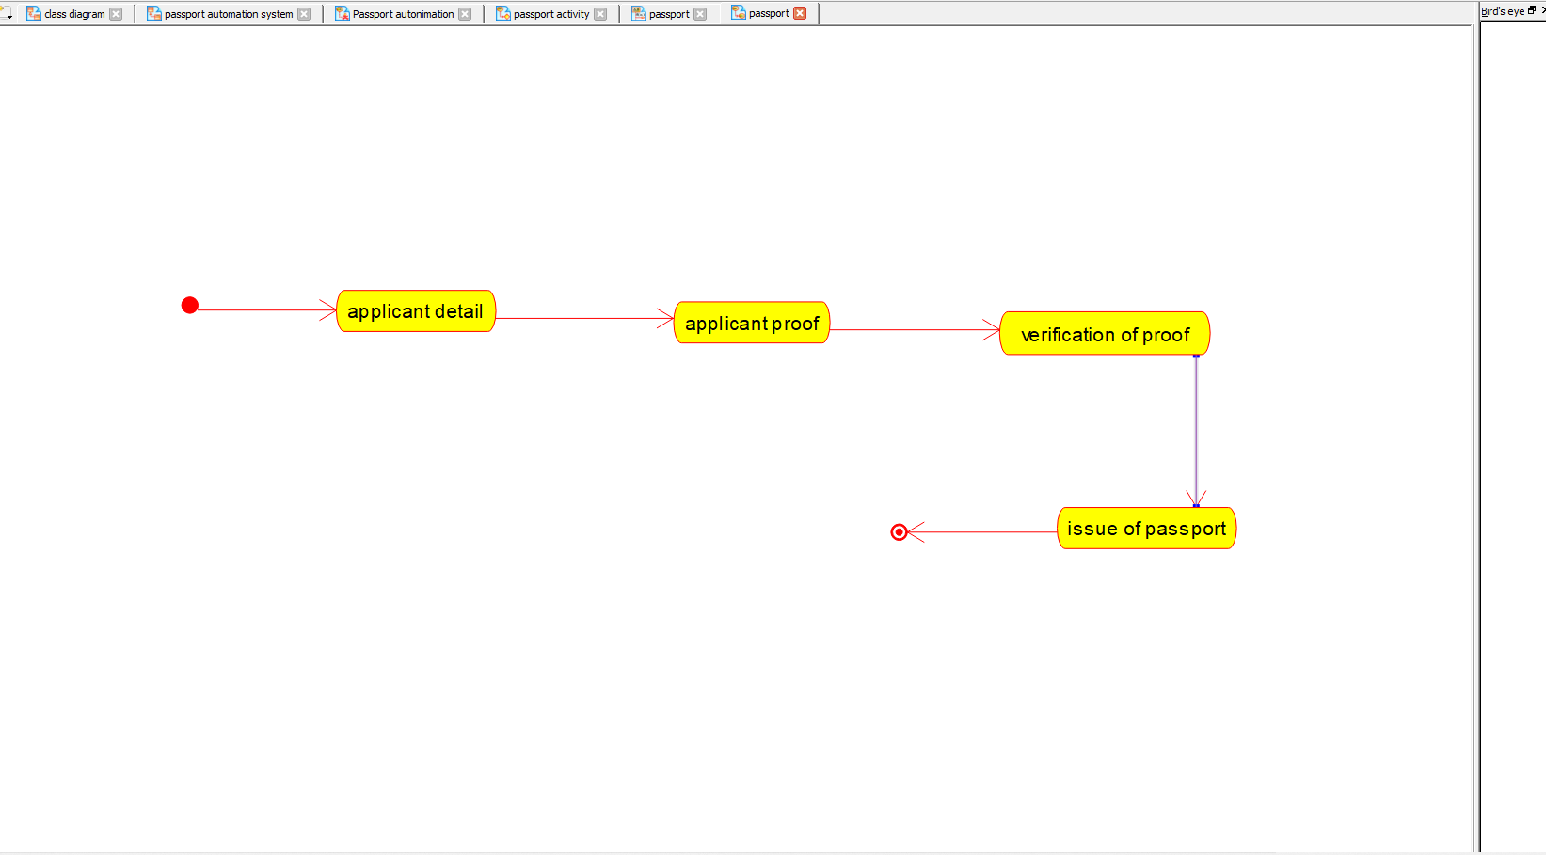

7.statechart diagram

Program coding:

/**

* Class APPLICANT

*/

public class APPLICANT {

//

// Fields

//

private void APPLICANT_NAME;

private String applicant_details;

//

// Constructors

//

public APPLICANT () { };

//

// Methods

//

//

// Accessor methods

//

/**

* Set the value of APPLICANT_NAME

* @param newVar the new value of APPLICANT_NAME

*/

private void setAPPLICANT_NAME (void newVar) {

APPLICANT_NAME = newVar;

}

/**

* Get the value of APPLICANT_NAME

* @return the value of APPLICANT_NAME

*/

private void getAPPLICANT_NAME () {

return APPLICANT_NAME;

}

/**

* Set the value of applicant_details

* @param newVar the new value of applicant_details

*/

private void setApplicant_details (String newVar) {

applicant_details = newVar;

}

/**

* Get the value of applicant_details

* @return the value of applicant_details

*/

private String getApplicant_details () {

return applicant_details;

}

//

// Other methods

//

/**

*/

public void apply_passport()

{

}

/**

*/

public void submission_of_proof()

{

}

}

/**

* Class ENQUIRY_OFFICER

*/

public class ENQUIRY_OFFICER {

//

// Fields

//

private String VERIFICATION_OF_DETAILS;

//

// Constructors

//

public ENQUIRY_OFFICER () { };

//

// Methods

//

//

// Accessor methods

//

/**

* Set the value of VERIFICATION_OF_DETAILS

* @param newVar the new value of VERIFICATION_OF_DETAILS

*/

private void setVERIFICATION_OF_DETAILS (String newVar) {

VERIFICATION_OF_DETAILS = newVar;

}

/**

* Get the value of VERIFICATION_OF_DETAILS

* @return the value of VERIFICATION_OF_DETAILS

*/

private String getVERIFICATION_OF_DETAILS () {

return VERIFICATION_OF_DETAILS;

}

//

// Other methods

//

/**

*/

public void Issue_of_passport()

{

}

/**

*/

public void renewal_of_passport()

{

}

}

/**

* Class PASSPORT_MANAGEMENT_SYSTEM

*/

public class PASSPORT_MANAGEMENT_SYSTEM {

//

// Fields

//

private String VERIFY_DETAILS;

private String STORE_PROOF

//

// Constructors

//

public PASSPORT_MANAGEMENT_SYSTEM () { };

//

// Methods

//

//

// Accessor methods

//

/**

* Set the value of VERIFY_DETAILS

* @param newVar the new value of VERIFY_DETAILS

*/

private void setVERIFY_DETAILS (String newVar) {

VERIFY_DETAILS = newVar;

}

/**

* Get the value of VERIFY_DETAILS

* @return the value of VERIFY_DETAILS

*/

private String getVERIFY_DETAILS () {

return VERIFY_DETAILS;

}

/**

* Set the value of STORE_PROOF

* @param newVar the new value of STORE_PROOF

*/

private void setSTORE_PROOF (String newVar) {

STORE_PROOF = newVar;

}

/**

* Get the value of STORE_PROOF

* @return the value of STORE_PROOF

*/

private String getSTORE_PROOF () {

return STORE_PROOF;

}

//

// Other methods

//

/**

*/

public void Issue_of_passport()

{

}

/**

*/

public void verification_of_passport()

{

}

/**

*/

public void cancellation_of_passpott()

{

}

}